**Our 7 Unique Day Rides**

*Ride times tailored for each group

**Ride 1 Sheep Station Creek Ramble**

Arrive at approx 9:30AM at the Wool Shed. The ride departs from here at around 10.00am. It begins with riding through undulating, open pastures and there is the opportunity to view some Snowy Mountains brumby mobs, which often have mares with foals at foot.

The ride then continues through the wilderness, along scenic spurs and through gullies brimming with wildlife such as Red Necked wallabies, eastern grey kangaroos and the odd echidna or wombat or maybe an emu or 2.

Following our Sheep Station creek north, the country becomes gradually steeper until the ride drops down to an emerald green grassy clearing on the creek, where lunch is scheduled.

After lunch, the ride continues to the base of our western mountain range. From there, it is a relatively steep climb to the top of Snowy Wilderness if you are camping at Bella Vista. Once at the top, it is a short ride to “Lake Bella Vista Camp Site” which could be the location of the first night’s camp. From the woolshed to the campsite, the ride will have travelled over 400 vertical meters. The afternoon is very scenic, with mountain gullies filled with ferns and native flowers and plenty of wild life including deer.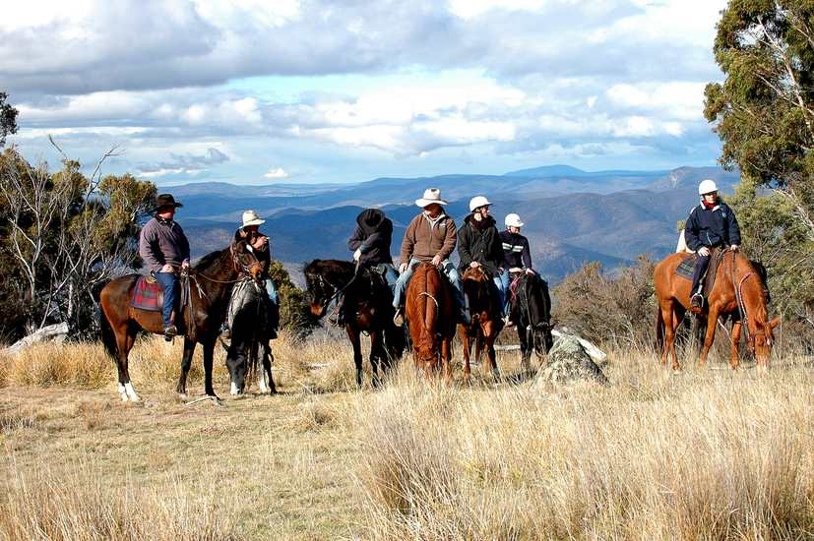

**Riders at Bella Vista**

Arrival at camp is usually 4:00PM and preparations for the evening meal including a large camp fire are well under way by the support group. Hot water is ready for the bush showers and tea/coffee, and of course your favourite drink.

Drinks and snacks at 5:00PM and Dinner at 7:00PM

**Ride 2 The High Acres Cruise**

The High Acres ride explores the top acreage of the property and is an easier day’s riding. Firstly, the ride visits a panoramic lookout point called Rocky Top Lookout , and at approximately 1350m, there is a brilliant view of the Snowy Wilderness backyard and a view of things to come! The view takes in Mt Carlisle, Sheep Station Creek, Reedy Creek and Gully Creek valleys, and 3 volcanic peaks named the Tubbits.

From the lookout, the ride explores the sub-alpine plateau and 5 mobs of brumbies including our Waler brumbies which were relocated to Snowy Wilderness. Waler brumbies are from the north of Australia and hold a unique position in Australia’s history as they are descended from horses of the 1st fleet and bred for Australia’s light horse cavalry. They are magnificent to see and you can get reasonably close to them

As the ride progresses, we visit the Snowy Wilderness truffle acreage, yes we are growing truffles just like France and Italy!!, as well as sweeping views across the top of Australia’s main range, which quite often has snow on it. Landmarks that can be seen here include Mt Kosciusko (Australia’s highest mountain at 2228m), Ramshead Range, and Mt Perisher.

After this, the ride moves on to “Powers Hut”, typical of wilderness huts found in our national parks and constructed in the early 1900’s. Power’s hut is 108 years old and the heritage of the Snowy Mountains is reflected in this building.

A lunch site is chosen and there is opportunity to relax and take in the majestic surroundings.

After lunch, the ride sets off in search of the Silver Brumby Mob. Led by a silver grey Waler stallion, this mob has mares who are different shades of grey and can be quite elusive, weaving through the grey snow gum trees. The Silver Brumby is a majestic horse and there is a series of children’s books in Australia called the Silver Brumby.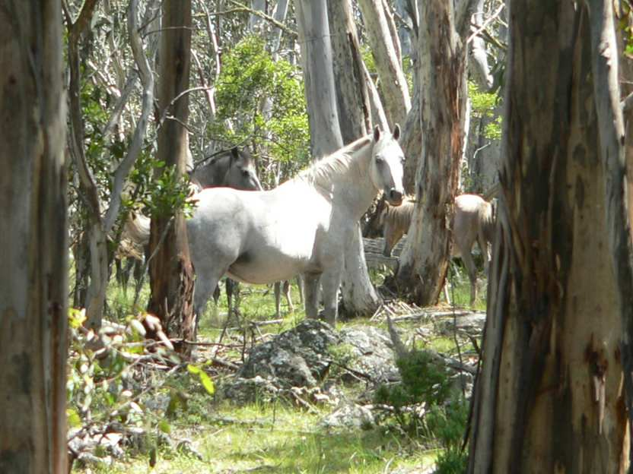

**Our magnificent Silver Brumby**

Following this, the ride moves through slightly thicker bush to a vantage point looking out toward Jindabyne takng in Mount Jillamatong.. The ride then descend into a lovely green glade and we also have a small jumps course for those experienced enough to safely jump, the others can look on. From here, there is a a picturesque ride to GlenView lunch spot with spectacular views east to the Tubbits volcanoes. Then it is on to Hidden Lake, if it is in summer we may go for a swim with our horses. for those experienced enough. Then it is back to the Bella Vista campsite.

Arrival back at Bella Vista Wilderness Campsite is usually 3:00PM and preparations for the evening meal including a large camp fire are well under way by the support group. Hot water is ready for the bush showers and tea/coffee.

Drinks and snacks at around 5:00PM and Dinner at 7:00PM

**Ride 3 The Northern Loop Ride**

This ride usually goes either from Bell Vista campsite or the Woolshed/Reception. the ride moves down past Hidden Lake which helps irrigate the oak/truffle trees, and begins a steep descent through a beautiful glade then onto a steep spur back down towards Sheep Station Creek. Once again, commanding views impress upon you as you ride down the trail. Sheep Station Creek is crossed, and a steady climb out of Sheep Station Creek valley onto a scenic track along a ridge which weaves down to the northern boundary of the wilderness. From here, it is trail riding at its best, across spurs and gullies with awesome “Man from Snowy River” views including a particularly steep cliff like view down onto a distant Reedy Creek. Then it is riding further down the spur to find a relatively easier descent into Reedy Creek where we find a very lush and green area to have lunch on the creek’s scenic banks.

After lunch the ride continues crossing Reedy Creek and proceeding around a steep mountainside, then descending along spur into Tin Mine Creek gully. We then climb up a ridge then over the top and down the other side back into the banks of Reedy Creek.

This is the start of our Beach Ride which is just terrific fun and nice easy riding. We meander along the sandy sides of the creek, sometimes with steep banks on each side, perfect for an ambush!! And just when you thought you were having real fun, we come to the last part of the beach Ride just before Reedy Creek Campsite where we go for a trot or canter along a lovely sandy stretch of beach.

We then ride on back up over a ridge back to our Homestead campsite.

Drinks and snacks, Dinner about 7:00PM

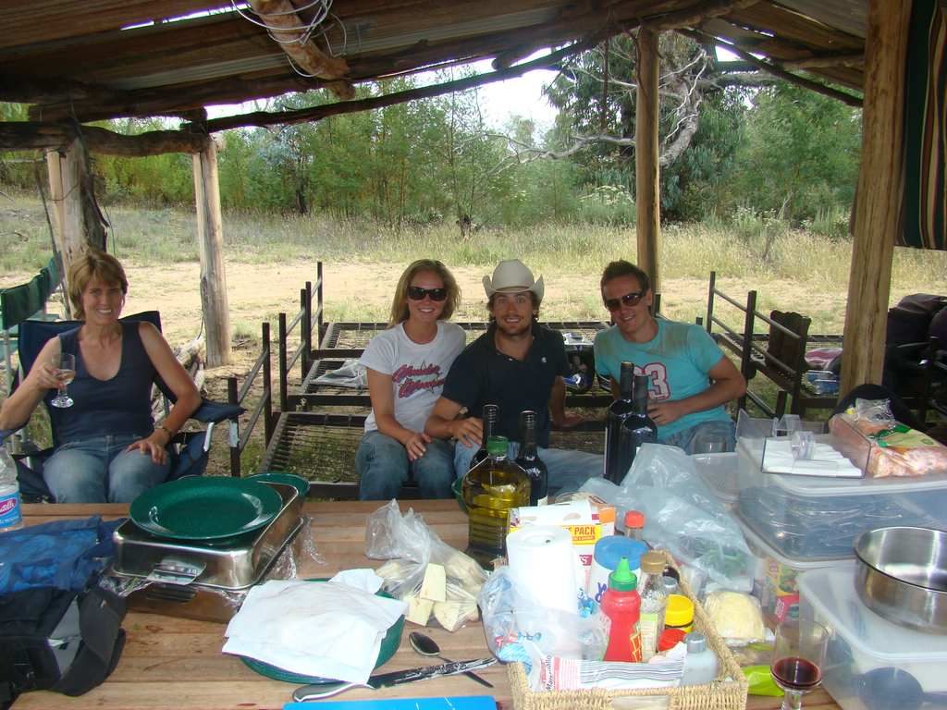

**Our Wilderness Camps are really great fun**

**Ride 4 Geehi**

Today after a hearty breakfast we saddle the horses and pack them onto the trailers for transport to Geehi Horse Camp over the Western side of the Main Range mountains. The Geehi Horse Camp has a river close by for the horses to have a drink and well established horse yards as well as storage shed, toilet and camp area.

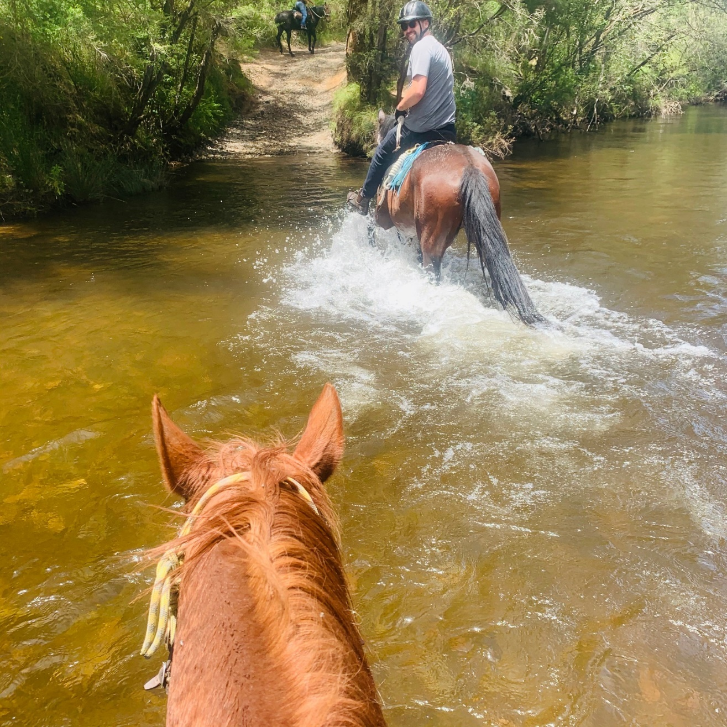

After a little set up time at camp we ride out to the Geehi general camping area to visit old Geehi Hut, river crossings through Swampy Plains River, riding to the start of the Geehi Wall 4wd trail. Then return to the Geehi Horse Camp for dinner.

**Ride 5 Geehi to Tom Groggin**

Today the ride takes the National Bi Centennial trail to Tom Groggin. This is a spectacular trail with many creek crossings and thick bush either side of the trail. On many occasion we can hear the loud barks of the large Sambar Deer and on occasion we do see some.

It is about 23kms of mountain trail riding with many opportunities to go for canters, in fact, we need to canter just to make up time.

From time to time we break out with spectacular views of surrounding alpine landscape. The odd sighting of other fauna interrupts the tranquility of this special trek. We stop for lunch literally on the trail, we are in the middle of nowhere with not a care in the world.

More creek crossings, a lot of up and down and the we break out into the emerald scenes of the Tom Groggin region with it’s glorious back drop of mountains and the Murray River, Australia’s biggest and longest river, but not so big at our camp site as it is very near the beginning of this incredible river system. Where the river starts, it is called the Indi.

Usually we are able to secure one of the camp sites on the banks of the river, but nothing is guaranteed!. We unsaddle and water and feed the horses, then settle into camp for drinks and dinner and for a swim in the Murray.

**Ride 6 Tom Groggin to Riley’s and back**

Today’s ride heads out south to locate the trail to Jack Riley’s Hut Site. Jack Riley was born in Ireland in the 1800’s and immigrated to Australia in 1851 settling in Omeo.

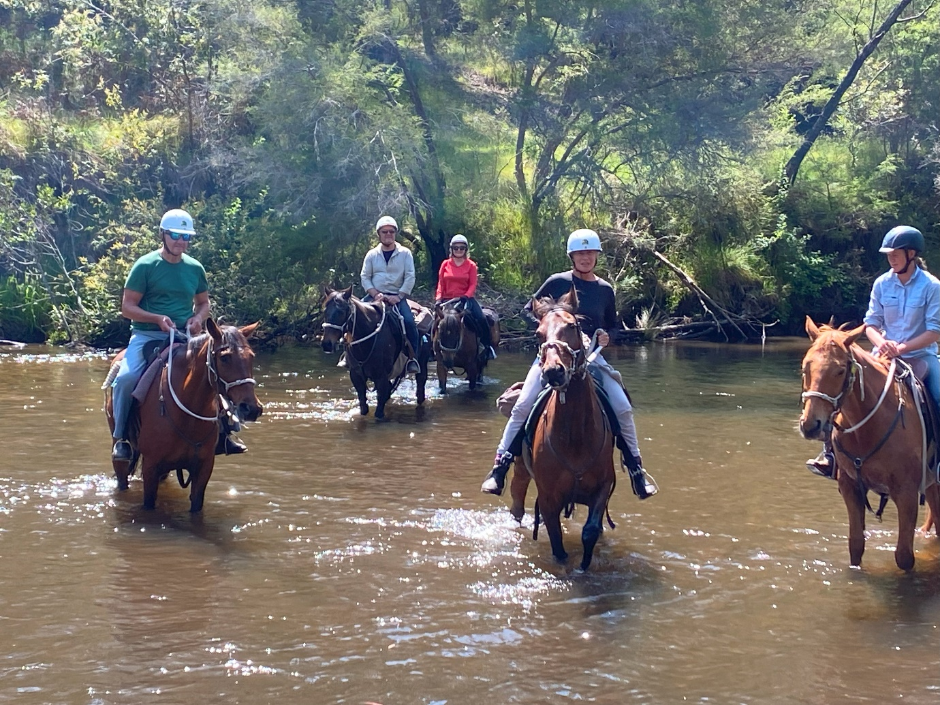

He worked as a stockman and ended up as manager of the then 20,000 acres of Tom Groggin Station. He is believed to be one of the characters from which Banjo Patterson based his Man from Snowy River poem. Jack Riley died from a heart condition in 1914 and is buried at the cemetery in Corryong.

His Hut no longer exists but a plaque is there in it’s place. The main part of the Hut was moved and constructed to the Victorian side of Tom Groggin but it got burnt down when one of the workmen was burning off blackberries.

We continue to follow the Bi Centennial trail and cross the Murray River into the State of Victoria and then head south alongside the Murray through spectacular scenery. After about an hour and a half, we then veer Westward and re cross the Murray River back into NSW where we have lunch.

At the location is the plaque where Riley’s hut existed. There are also 3 or 4 mobs of beautiful Brumbies in this open tract of Alpine meadow.

After a leisurely lunch we then get back into the saddle and head back Northwards, again through spectacular gum trees, bush, and scenery. We ride back over some creeks and finally back to Tom Groggin.

We load the horses back into our trailers and slowly drive back over the mountains, down past Thredbo then Jindabyne and back to Snowy Wilderness, unsaddle the horses and say our sad goodbyes, hugs and best wishes.